
Voting Bin Locations – Accessibility Information
This document is a list of the voting bin locations for the by-election 2026. The information for each location includes:
- Address
- Opening hours
- Number and location of mobility parks
- Information about surfaces, ramps and steps
- Details about places to sit
- The people at the location who can answer questions
- Pictures of the exterior

You can also view an interactive digital map on your phone. You can do this by:
- visiting this webpage: https://discoverwhakaoriori.stqry.app/tour/56613 or
- downloading our free app on your phone. Follow this link https://qrco.de/mstn or scan the QR code with your phone camera

Need help to vote? We can come to you. Get in touch with us to organise a time by:
- emailing harrietk@mstn.govt.nz or
- calling 06 370 6300
Or you can use the telephone dictation service by calling 0800 666 040.

Table of Contents
Waiata House 3
Paper Plus 4
Masterton District Library 5
New World Supermarket 6
Woolworths Supermarket 7
Mitre 10 Mega 8
The Warehouse 9
Solway Supermarket 10
Trust House Recreation Centre 11

Waiata House
Address:
27 Lincoln Road, Masterton
Opening Hours:
Monday – Friday: 9am – 4pm
Weekends: Closed
Location information:
- There is one mobility park at the side of the building next to the entrance
- The path to the door is asphalt and concrete
- There are no ramps or steps to enter.
- There are two sets of electric doors activated by a sensor. The space between them is similar to a bank.
- There is a receptionist at the front desk who can answer questions.
- There are low couches and soft chairs in the foyer that you can sit on.
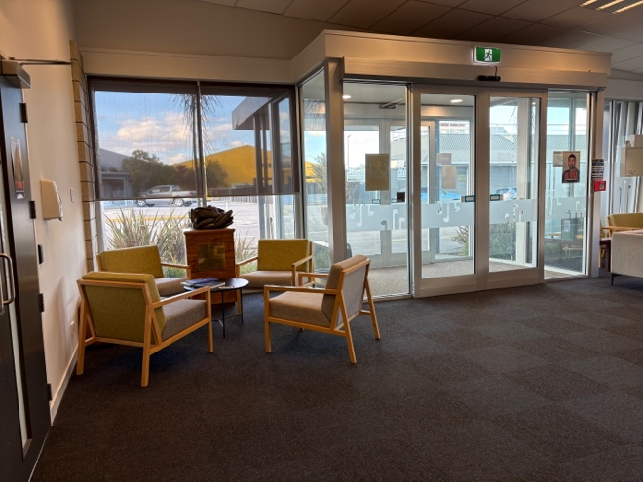
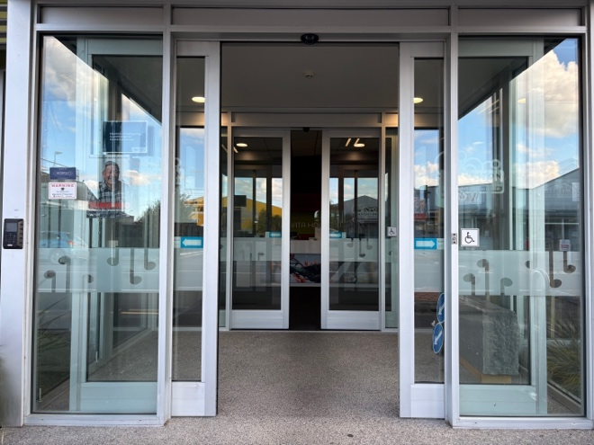
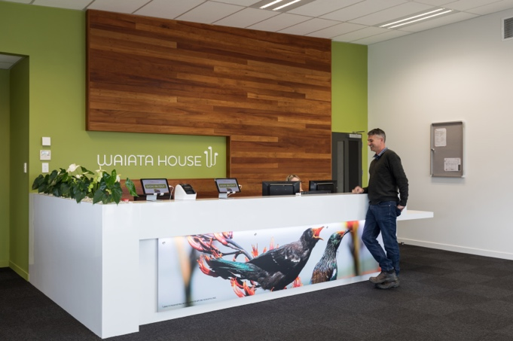
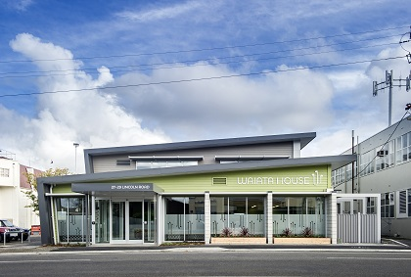
Location Photos:

Paper Plus
Address:
181 Queen Street, Masterton
Opening Hours:
Monday – Saturday: 9am – 5:30pm
Sunday: 10am – 4pm
Location information:
- There is a mobility park on Queen Street on the other side of the road, opposite the front entrance.
- There are mobility parks in the Uncle Bill's carpark, you can use Charlie's Lane to access the side entrance.
- The paths to the doors are all asphalt and concrete.
- There are no steps or ramps required to enter.
- There are electric doors to enter the building that are triggered by an overhead sensor.
- There are benches to sit on in the lane outside the shop.
Location photos:

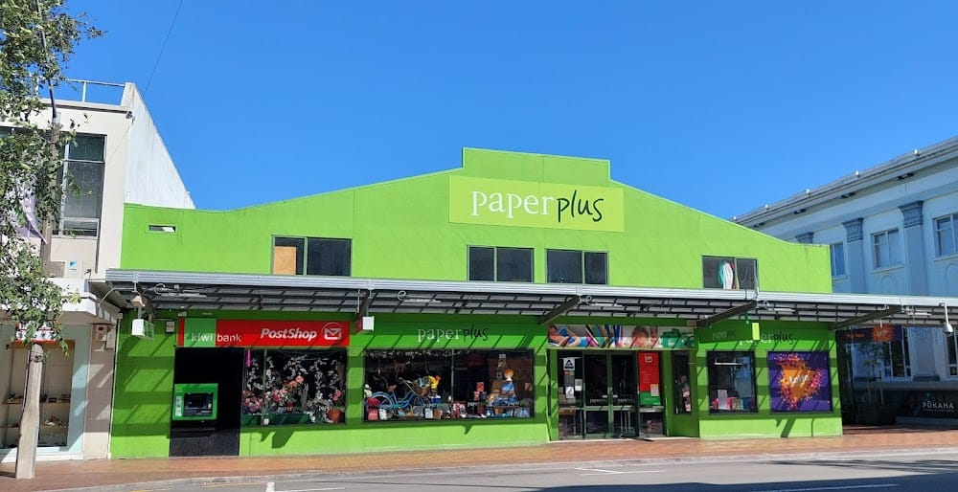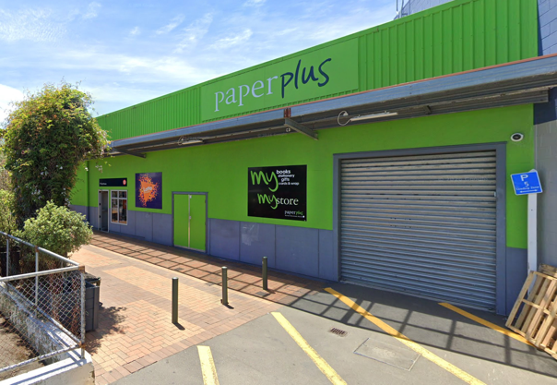

Masterton District Library
Address:
54 Queen Street, Masterton
Opening Hours:
Monday, Tuesday and Wednesday: 9:30am – 5:30pm
Thursday: 9:30am – 6:30pm
Friday: 9:30am – 5:30pm
Saturday: 9:30am – 1pm
Sunday: Closed
Location information:
- There is a mobility park on Queen Street near the entrance.
- The path to the door is all asphalt and concrete.
- There are no steps and there is a gentle incline to the entrance.
- There is one set of electric doors to enter the building that are triggered by a sensor.
- There are librarians available who can answer questions.
- There are chairs and tables that you can sit at.
- There is also a rear entrance with electric doors that is accessible from the carpark behind library square.
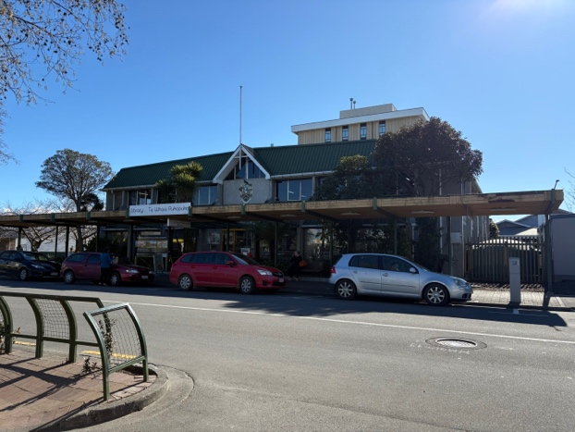
Location photos:
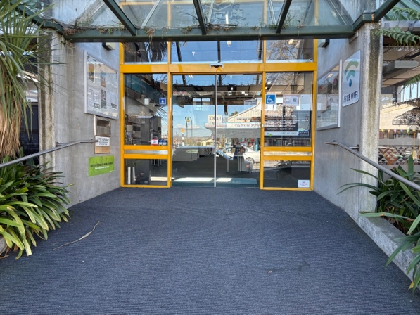
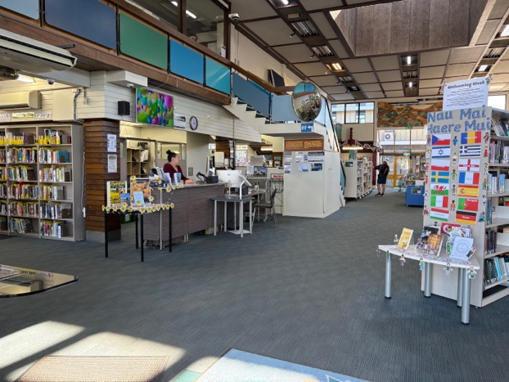
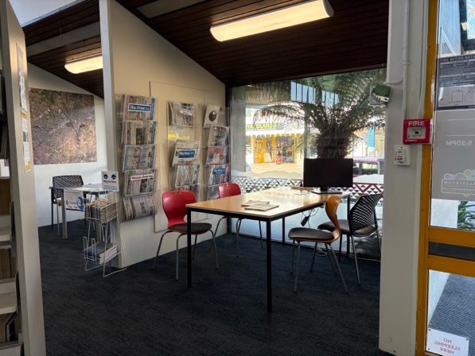

New World Supermarket
Address:
Corner of Bruce Street and Dixon Street, Masterton
Opening Hours:
Monday to Sunday: 7am – 9pm
Location information:
- There are two mobility parks at the entrance.
- The path to the door is asphalt and concrete.
- There are no steps or ramps to enter.
- There are two sets of electric doors to enter the building that are triggered by a sensor.
- The staff can’t answer questions.
- There are benches outside the shop that you can sit on.
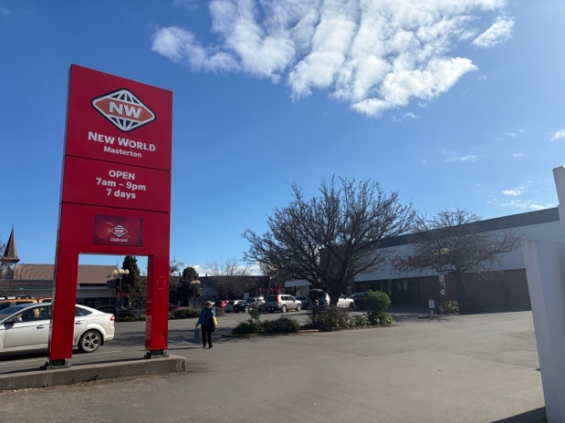
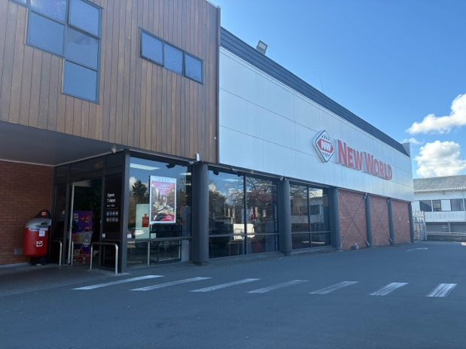
Location photos:

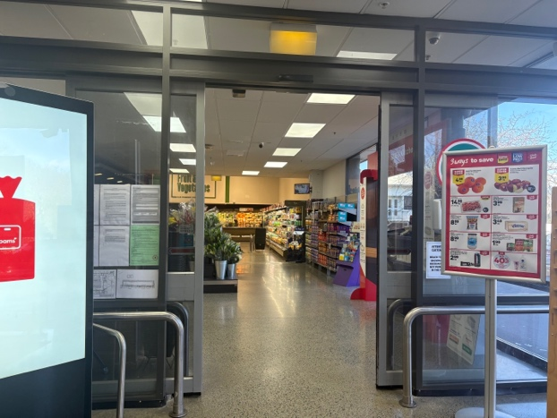
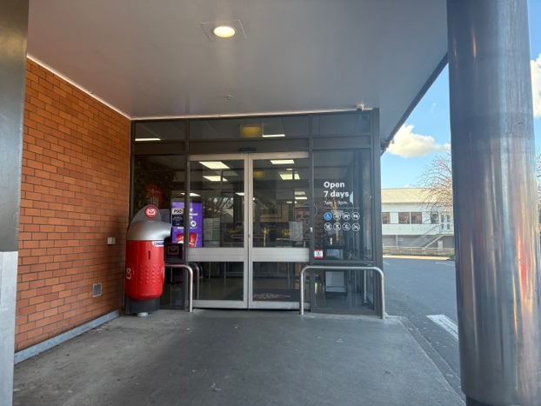

Woolworths Supermarket
Address:
Corner of Worksop Road and Queen Street, Masterton
Opening Hours:
Monday to Sunday: 7am – 9pm
Location information:
- There are four mobility parks at the entrance.
- There are three parent parks at the entrance.
- The path to the door is asphalt and concrete.
- There are no steps or ramps.
- There is one set of electric doors to enter the building that are triggered by an overhead sensor.
- There are metal one way gateline/turnstiles.
- The staff can’t answer questions.
- There is a bench outside that you can use.
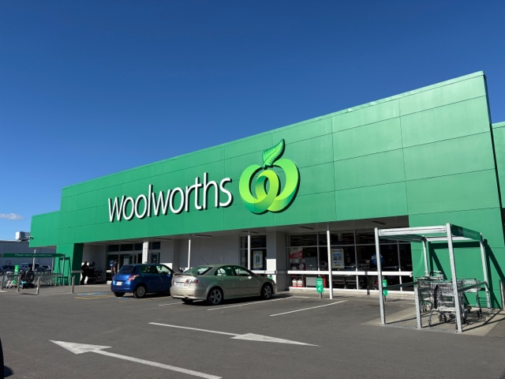
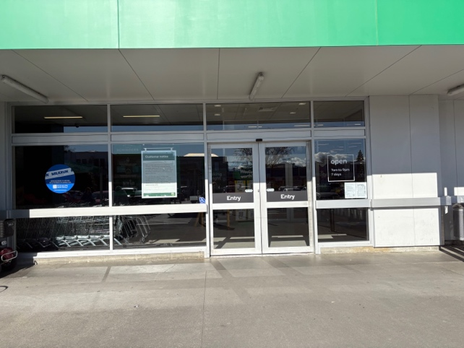
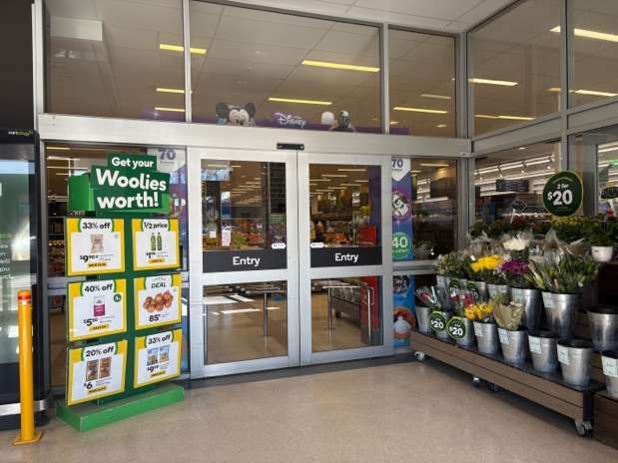
Location photos:

Mitre 10 Mega
Address:
159-167 Ngaumutawa Road, Masterton
Opening Hours:
Weekdays: 7am – 6pm
Weekends: 8am – 6pm
Location information:
- There are four mobility parks at the entrance.
- There are three parent parks at the entrance.
- The path to the door is all asphalt and concrete.
- There are no ramps or steps to enter.
- There is an electric door to enter that is triggered by a sensor. These doors only open from the outside, once you enter you will need to go through the store and exit through the till area unless you wait for someone else to enter when the doors will open again.
- There are metal one way gateline/turnstiles into the store.
- The staff can’t answer questions.
- There is a bench outside that you can sit on.
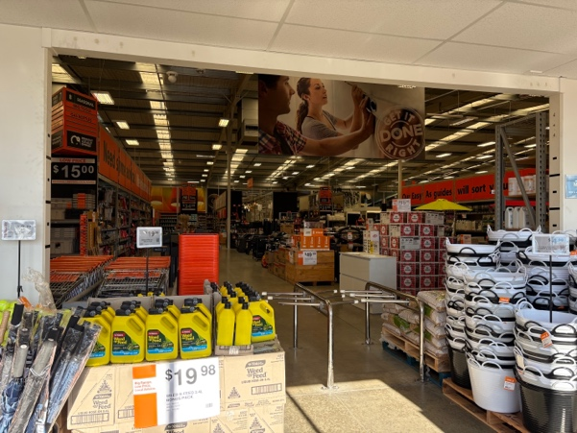
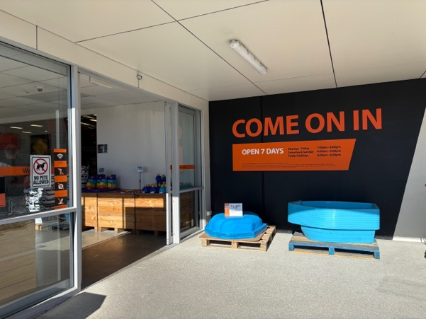
Location photos:

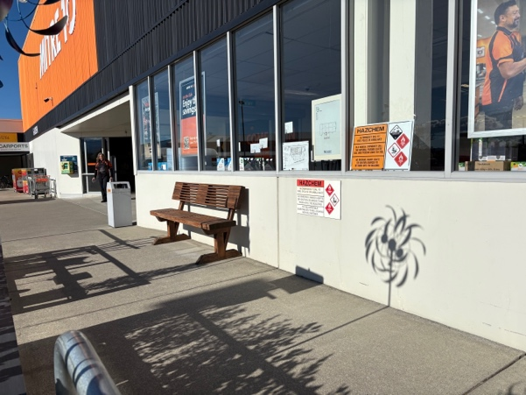

The Warehouse
Address:
Corner of Chapel Street and Russell Street, Masterton
Opening Hours:
Monday to Sunday: 8am – 9pm
Location information:
- There are three mobility parks at the entrance.
- The path to the door is all asphalt and concrete.
- There are no ramps or steps to enter.
- There are two sets of electric doors to enter that are triggered by a sensor.
- The staff can’t answer questions.
- There is a bench inside the foyer that you can sit on.

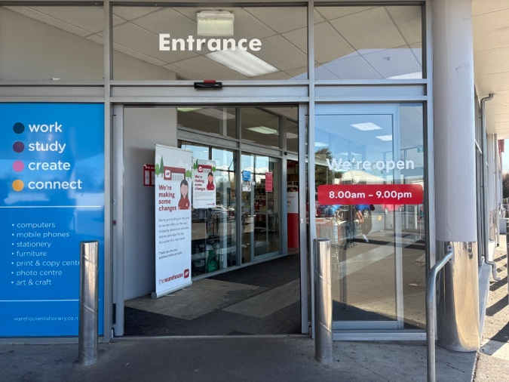
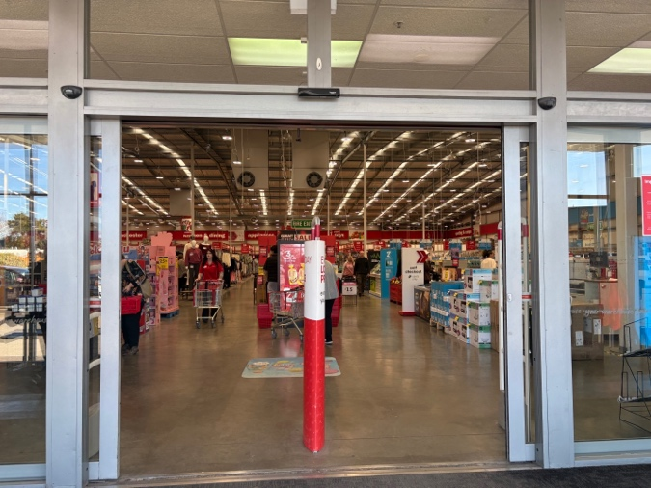
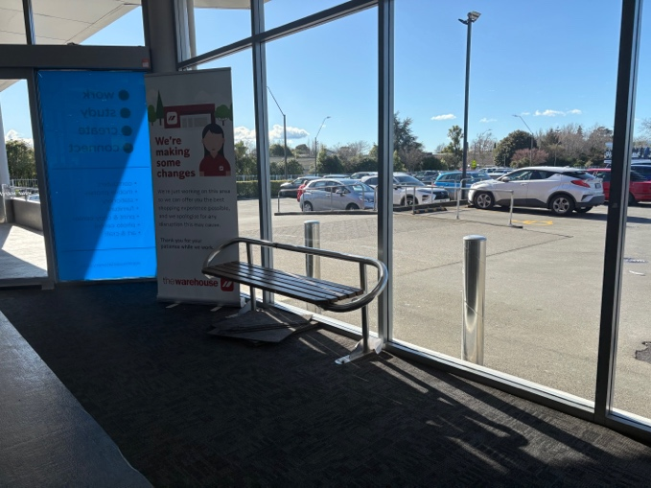
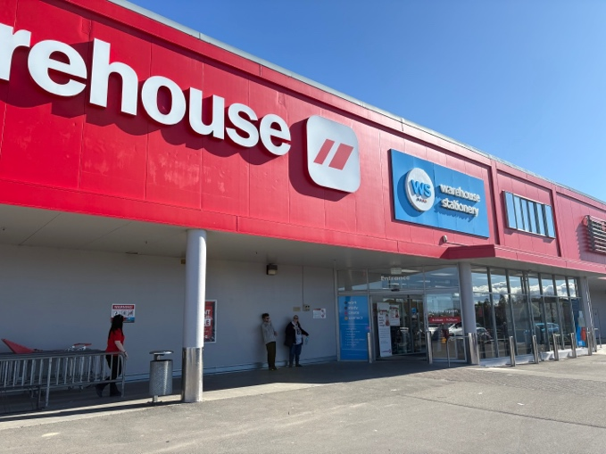
Location photos:

Solway Supermarket
Address:
218 High Street, Masterton
Opening Hours:
Weekdays: 6am – 8pm
Saturday: 7am – 8pm
Sunday: 8am – 7pm
Location information:
- There are two mobility parks outside the entrance.
- The path to the door is all asphalt and concrete with a cut curb.
- There is a bollard in the middle of the entrance which may block the entrance for power chairs and large wheel chairs.
- There are no steps or ramps required to enter.
- There is one set of electric doors to enter the building that are triggered by an overhead sensor.
- The staff can't answer any questions.
- There are no places to sit down.
Location photos:
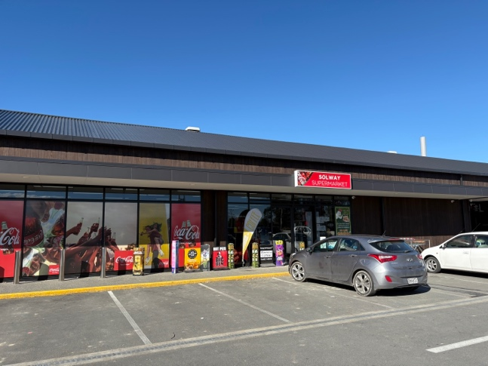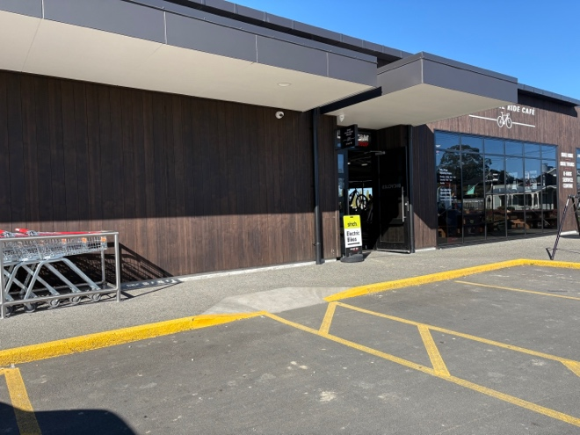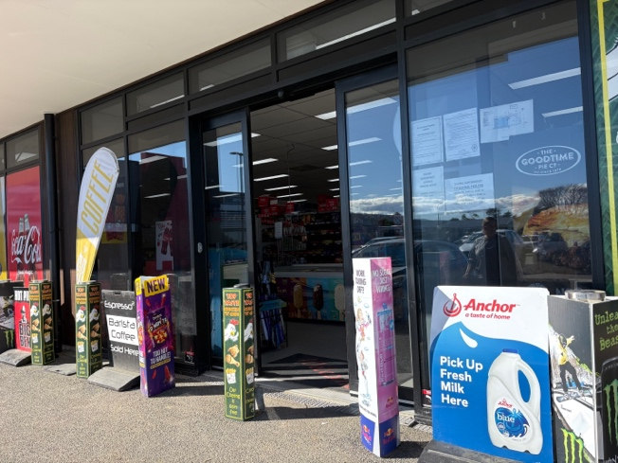

Trust House Recreation Centre
Address:
2 Dixon Street, Masterton
Opening Hours:
Weekdays: 5:30am – 8pm
Weekends: 8am – 6pm
Location information:
- There are two mobility parks on the street opposite the entrance.
- There is a pedestrian crossing with curb cuts and hard surfaces from the parks to the entrance.
- There are no ramps or steps to enter.
- There is one set of electric glass doors that are automatically triggered by a sensor.
- There are several chairs and benches available for you to sit on.
- There will be a person at reception but they might not be able to answer questions.

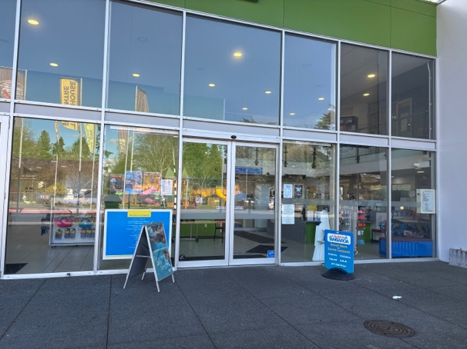
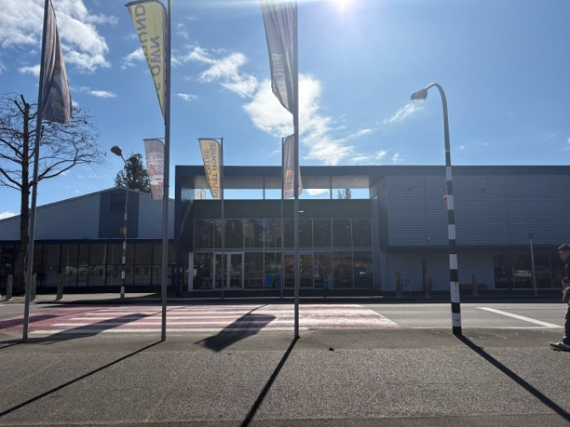
Location photos:
