Te Hōkai Nuku WAIRARAPA REGION POSITIVE AGEING STRATEGY

For the District Councils of South Wairarapa, Carterton and Masterton 2019

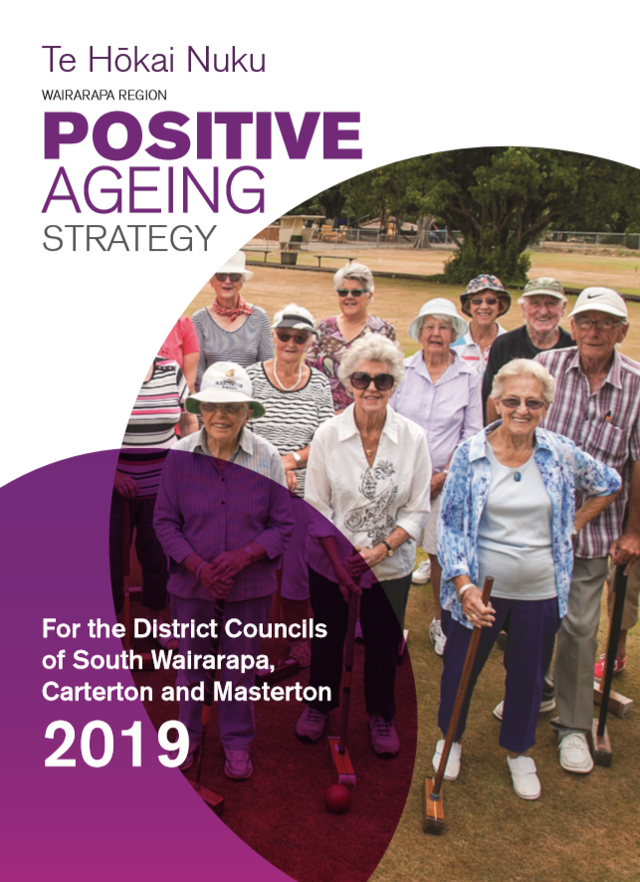

Cover image of the Wairarapa Regional Positive Ageing Strategy – Te Hōkai Nuku

Tēnei au Tēnei au
Te hōkai nei o taku tapuwae
Ko te hōkai nuku ko te hōkai rangi
Ko te hōkai a tō tipuna a Tānenui-a-rangi
Ka pikitia ai ki te rangi tūhāhā ki te Tihi-o-Manono
Ka rokohina atu rā ko Te Io-Matua-Kore anake
Ka riro iho ai ngā kete o te wānanga
Ko te kete-tuauri
Ko te kete-tuatea
Ko te kete-aronui
Ka tiritiria ka poupoua
Ka puta mai te ira tangata
Ki te whaiao ki te aō mārama
Tihei Mauriora
Contents
Foreword from the Mayors 3
Kupu Whakataki mai i ngā Koromatua
Welcome from the Steering Group and Sponsors 4
Whakatau o te Rōpū Whakahaere
Vision 5
Wawata Mātāmua
Values/principles Guiding the Strategy 5
Whanonga Ārahi
Strategic Alignment 7
Rautoki Hononga
Strategic goals 8
Ngā Rautaki Whāinga
Goal one: Community Support and Health Services 9
Whāinga Tuatahi: Hauora Ratonga Hapor
Goal Two: Communication and Engagement 11
Whāinga Tuarua: Whakaputa Kōrero, Whakawhitiwhiti Kōrero
Goal three: Transport 13
Whāinga Tuatoru: Waka Hari Tāngata
Goal Four: Cultural Diversity 14
Whāinga Tuawhā: Taha Tikanga Rerekē
Goal Five: Housing 16
Whāinga Tuarima: Whakakāinga Hauora
Goal Six: Places, Spaces and Activities 17
Whāinga Tuaono: Ngā Wāhi, Ngā Rēhia
Appendices 19
Ngā Tāpiritanga
Appendix one: Background 19
Appendix two: Contributors 23
Appendix three: Implementation Plan 24
Foreword from the Mayors

Kupu Whakataki mai i ngā Koromatua

We want everyone in Wairarapa to lead valued, connected and fulfilled lives. This means meeting wellbeing needs and achieving positive outcomes for all residents – young, old and everyone in between. The Wairarapa Positive Ageing Strategy has been developed by the three Wairarapa district councils to prepare for our rapidly ageing community.
In the next 25 years, the number of Wairarapa residents aged over 65 is expected to increase by about 79 per cent to nearly 15,000 – that’s one in four residents. We all want to live in an age-friendly world that enables people of all ages to actively participate in community activities.
And we all want to be treated with respect, regardless of our age.
Following extensive local research and community engagement, we are pleased to launch this new joint council strategy for Wairarapa. It outlines the ways in which the Masterton, Carterton, and South Wairarapa district councils will work together to ensure our older community is both valued and looked after.
Positivity is a keyword. Sometimes ageing is portrayed as negative and we need to be conscious of that and realise that’s not how our older residents see themselves. This strategy looks at simple things that can make a huge difference, like transport, connection, and accessibility.
Other key goals for this strategy include community support and health services, communication and engagement, cultural diversity, housing, and places, spaces and activities.
The government recently released its Better Later Life strategy, which was designed to test our thinking and focus on the priorities for action to help ensure New Zealand is a great place to age.
The Wairarapa Positive Ageing Strategy is our answer to this, because we want our beautiful region to be an amazing place for all its citizens to live in and enjoy. This document has been tailored to what our community has been telling us, and we believe it has the necessary ingredients to help our kaumātua/older adults lead connected and fulfilling lives by ensuring we create opportunities for everybody to participate, contribute and be valued as they age.
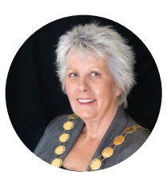

“It’s about integrating. We have an ageing population alongside strong growth in younger demographics; how do we cater to all? Simple things can make a huge difference – transport, connection, accessibility.” MDC Mayor Lyn Patterson

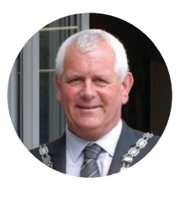
“My hope is that this strategy will help us create a community in Wairarapa where all people can stay connected, and will ensure things such as technology don’t become a barrier” CDC Mayor John Booth

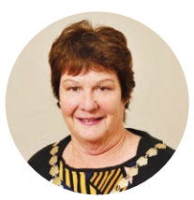
“Our growing ageing population is an integral part of our community and has so much to offer. This strategy will go a long way to helping our kaumātua lead enriched and meaningful lives” SWDC Mayor Viv Napier

Welcome from the Steering Group and Sponsors

Whakatau o te Rōpū Whakahaere

For some time, the South Wairarapa, Carterton and Masterton district councils have recognised the need to prepare for our rapidly ageing population. As the sponsors and steering committee of this strategy, we feel privileged to have been involved in its development, and look forward to its guidance in enhancing the lives and experiences of older people in our community.

We wish to wholeheartedly thank those who gave their time and energy to complete surveys, attend workshops, participate in focus group discussions and provide feedback. We have been delighted with the community’s strong interest and contribution. Through this, we learned just how important it is to take a strengths-based perspective and understand that ‘positive ageing’ for older people, also means positive ageing for all generations.

We would also like to thank elected members and council staff who engaged so constructively in this process. Understanding that there may be significant changes to the way councils think and work, our councils are excited about meeting challenges, and discovering and fostering new opportunities that older people offer the community.

Lastly, we are greatly appreciative to the Office for Seniors for providing the opportunity to undertake this work, and utilise the skills of Esther Bukholt of Solstone, who we thank for her motivation, knowledge and commitment to an authentic engagement process.

Ngā mihi nui

Sponsors
Jennie Mitchell, Group Manager Corporate Support, SWDC
Carolyn McKenzie, Community Services Manager, CDC Andrea Jackson, Manager Community Facilities and Activities, MDC

Steering Group
Amy Wharram, Communications Manager, SWDC
Gerry Brooking, Community Development Coordinator, CDC
Hoani Paku, Former Māori Liaison Officer, MDC
Aaron Bacher, Community Development Advisor, MDC

Vision

Wawata Mātāmua
Our kaumātua/older residents lead valued, connected and fulfilling lives

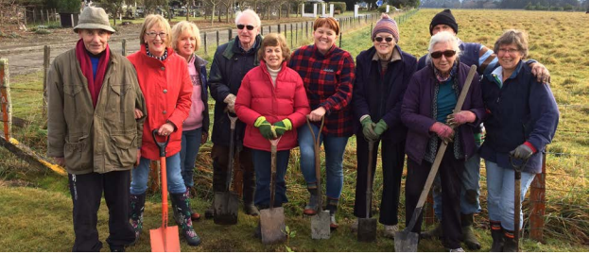

Values/principles Guiding the Strategy

Whanonga Ārahi

In order for the Positive Ageing Strategy to achieve successful outcomes for older people, the following underpinning principles have been identified through research and consultation:

A positive narrative
Growing old is a gift and a privilege denied to many. While it comes with new challenges, there are also many opportunities to be celebrated and embraced. The Wairarapa community strongly voiced a desire for councils to ensure positive images and narratives of our older people wherever they are represented.

Work together to build on what already exists
The three Wairarapa district councils have chosen to work together on this strategy in the knowledge that this will give the greatest benefit for older people in the region. There are also a large number of services and facilities that enable older people to live fulfilling lives. Working collaboratively will enable us all to achieve more for our ageing population.

Ensure equity
Many older people in Wairarapa enjoy lives that already reflect the Positive Ageing Strategy vision. There are others who do not. Targeted actions will be required to ensure equity of outcome for all Wairarapa older people in particular for people with inequities related to income, health, rural locations and ethnicity.

Cultural diversity
We have a culturally diverse region and research suggests this is expected to increase. Each of the councils has a governance relationship with iwi; however, further development is required to ensure strong, responsive relationships and support of other Māori and ethnic communities.

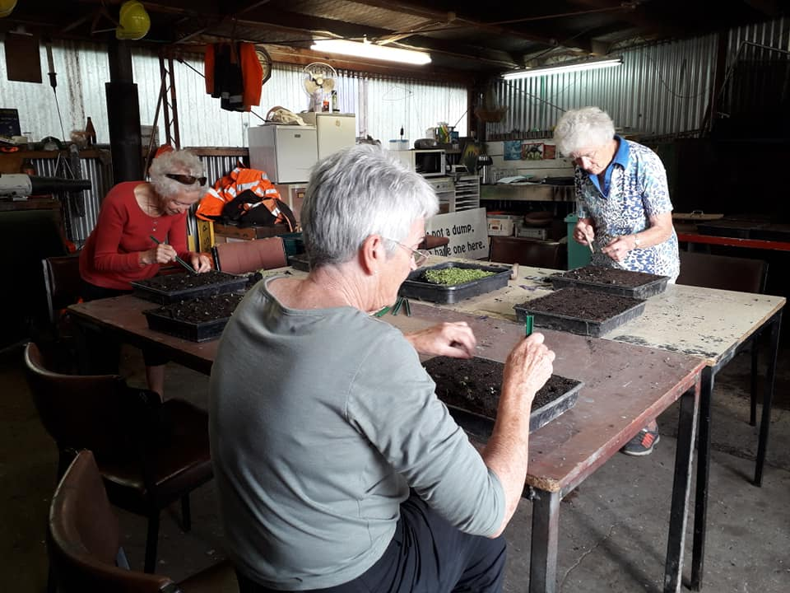

Strategic Alignment

Rautoki Hononga

The three Wairarapa district councils have a wide range of strategies, joint policies, and plans, as well as advice from advisory groups and forums to inform their work programmes, including support and services for older people. In addition, iwi, central government and community organisations have plans and strategies for supporting older people.

The aim of the Positive Ageing Strategy is to coordinate the activities of the three Wairarapa Councils, in a way that complements the work of local organisations working in this sector. Where possible, iwi, government and community organisations’ plans have been identified and referenced in this document.

Examples of key documents the Positive Ageing Strategy aligns to are:
National plans | Regional plans
Positive Ageing Strategy Aotearoa/New Zealand | Wairarapa Combined District Plan
Healthy Ageing Strategy | Wairarapa Regional Economic Development Strategy

Examples of council plans include:
South Wairarapa District Council | Carterton District Council | Masterton District Council
Long Term Plans
Spatial Plan (in development) | Urban Growth Strategy | Wellbeing Strategy – He Hiringa Tangata, He Hiringa Whenua

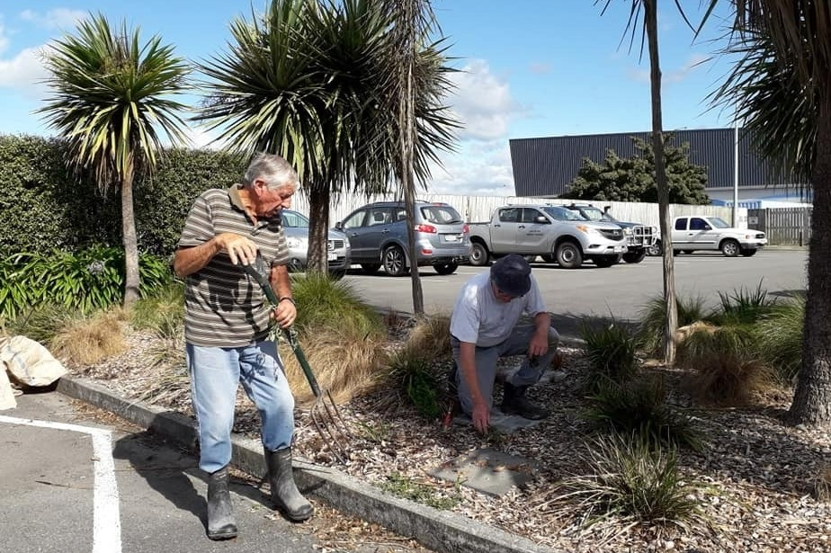

Strategic goals

Ngā Rautaki Whāinga

The strategic goals are based on the World Health Organisation Age-Friendly priorities and Office for Seniors Positive Ageing Strategy which were developed after considerable consultation internationally and nationally. The specific goals chosen for Wairarapa were selected through local research and consultation, and subsequently prioritised by elected officials. These are: 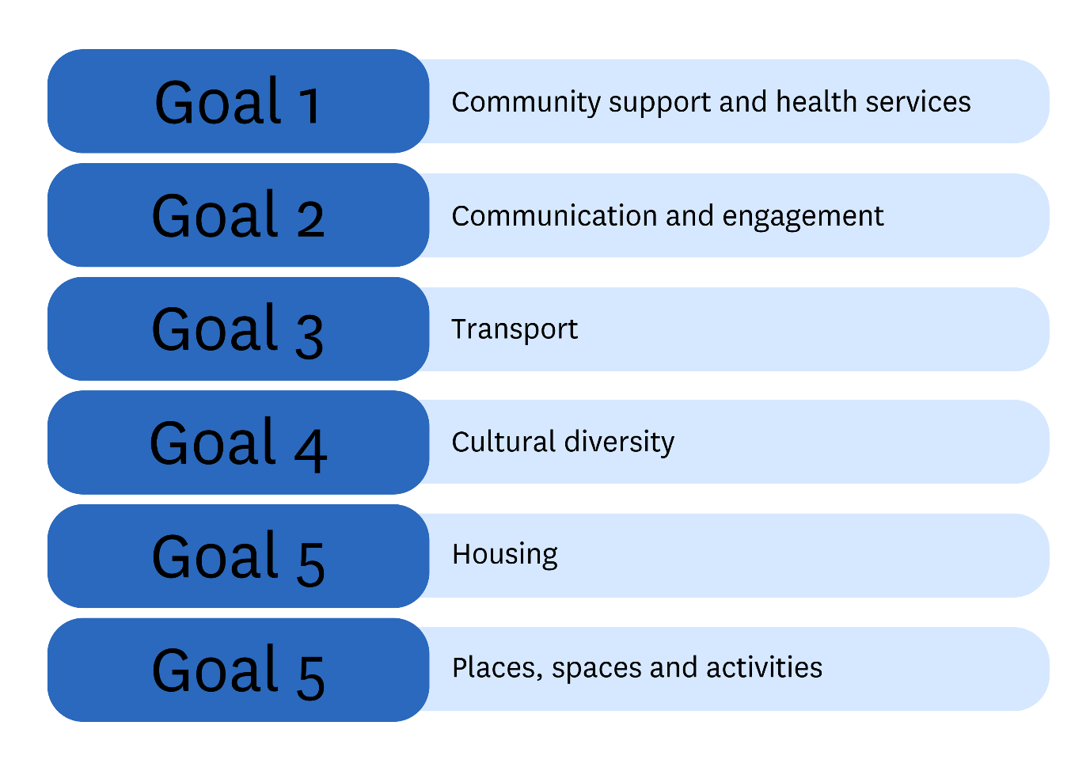

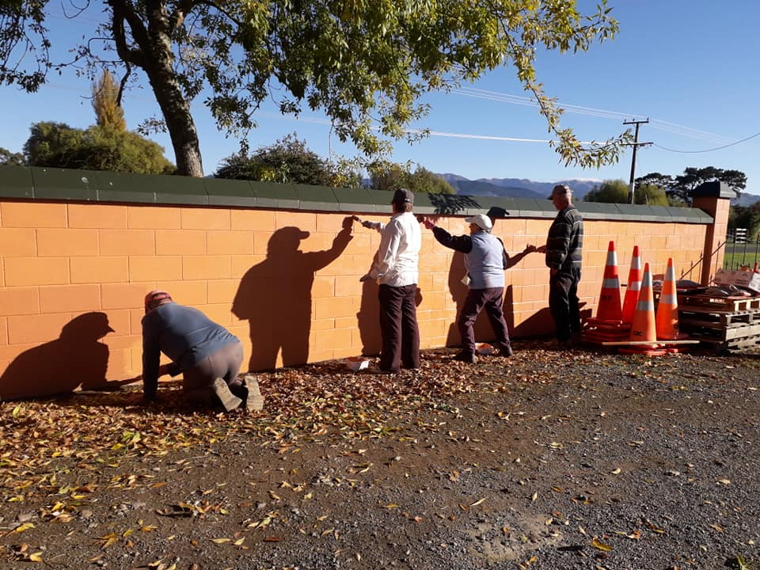

Goal one: Community Support and Health Services

Whāinga Tuatahi: Hauora Ratonga Hapori
Community and health services support older peoples’ well-being

Goal Overview

There are a wide variety of health and community services for older people in the region that support health and wellbeing. These are provided or funded by the public, private and not-for-for profit sectors.

Consultation with the public health sector identified that the ageing in place and patient/whānau centred care. is changing the nature of health provision in Aotearoa/New Zealand and in Wairarapa. It also identified a need for older people and their families to be individually more responsible for their own health.

Many smaller not-for-profit health organisations identified themselves as being under stress and are calling for more support and integrated services. They described themselves as working in isolation, and report being under pressure due to directives from their national bodies, lack of volunteers, lack of funding, and lack of paid staff. Private sector providers recorded fast growing demand for their services.

Health is not just the absence of disease. Loneliness has a strong relationship with poor mental and physical health outcomes. In the Wairarapa, 29% of people over 65 live alone compared with 26% across NZ.

Residents feedback:
“Sometimes, people are accessing health care, not because they are unwell but needing reassurance and connection.” Compass Health Manager
- A great deal of positive feedback was received from local residents about the services, activities, venues and open spaces that support health, community connection and well-being
- Many residents are happy with the standard of health care provided in Wairarapa, although lack of access and a shortage of GPs was identified as a huge issue
- Residents disadvantaged by health, income or ethnicity were less likely to know about and access services and activities they needed.
“Insufficient doctors to cover older persons needs and long waiting times for access. Need to sell the Wairarapa to new doctors.” Survey respondent, resident

Community, health, iwi and business organisations providers would like councils to focus on:
- Provision of service and infrastructure that improves wellbeing, connection and active lifestyles such as open spaces, community activities and community connection initiatives e.g. Neighbourhood Support
- Building relationships and identifying opportunities to work in partnership with the health sector
- Supporting equity of access, such as Community Health and Social Navigators. A limited number of these roles exist in some contracted services with not-for-profit organisations such as Whaiora
- Enabling more support and integrated services
- Māori health organisations in particular would like to see a change from a contract funding approach to a more wholistic commission approach.

Goal Priorities

- Ensure community and health related services support older peoples’ well-being by:
- Providing high-quality spaces, parks, activities, services and corridors that are safe and accessible for older people
- Supporting the capability and capacity of groups and organisations that provide community health services to older people.

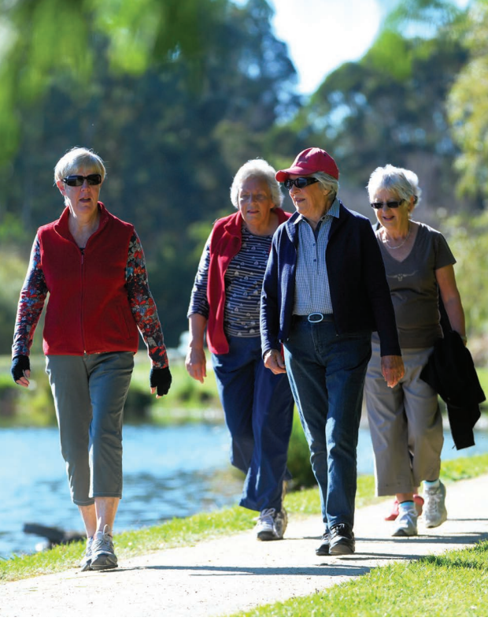

Goal Two: Communication and Engagement

Whāinga Tuarua: Whakaputa Kōrero, Whakawhitiwhiti Kōrero
Communication and Engagement with older people is respectful, appropriate and engaging

Goal overview
“We need to develop a process for timely consultation/info to councillors from older people.” Positive Ageing Strategy community consultation workshop participant

Other councils across the country with a positive ageing strategy have established
routes for engagement with older people such as an Elder Network, or Older Adults Advisory Group. This formed an important part of their strategy development processes. The Wairarapa district councils do not have such a structure in place, and in the general course of business, rely on their personal involvement with, and links to, the community.

On the communication front, the growing focus on providing online communications has led to a digital divide for a certain proportion of the population and this was repeatedly talked about in surveys and meetings. Wairarapa has a range of services working to
increase digital access for older people including SeniorNet, Digital Seniors and the local libraries. It is also increasingly recognised that communication with older people requires different strategies than with younger populations.

Valuable local information targeted to older people is also available online through the Wairarapa District Health Board website for older people at www.wairarapa.dhb.org.nz/ your-health/older-people. The Ministry of Social Development Super Seniors website has information for older people and their families at www.superseniors.msd.govt.nz.
“Consideration should be given to the fact that not all older people have access to a computer or are computer literate. Often we’re referred to websites for information.” Survey respondent, resident

Free community newspapers, printed material, radio and television remain important sources of information for older people who may not use the internet or buy newspapers and magazines. Free community papers include Wairarapa Midweek, Carterton Crier, Greytown Grapevine, Featherston Phoenix and Martinborough Star.
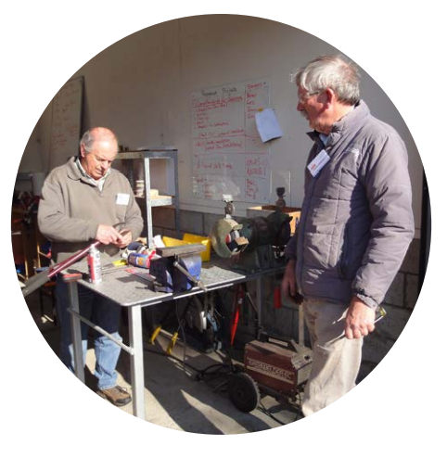

Community Leaders called for:
- A positive narrative about ageing
- Awareness training on communicating with older people for council staff, particularly for communication and frontline staff, best practice universal communication for older people and those with disabilities
- Elder Network and/or Older Persons Hub as a communication and engagement channel for councils.

Goal priorities
Ensure communication and engagement with older people is respectful, appropriate and engaging by:
- Targeted communication and customer service for older people from councils
- Regular, timely and appropriate advice to Councils on matters relevant to older people.

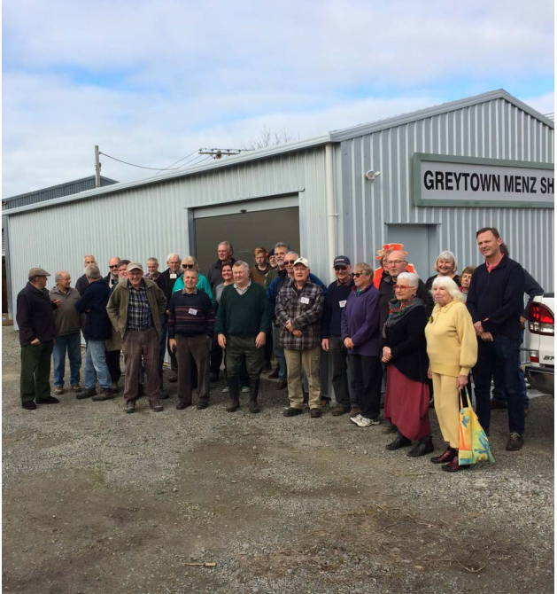

Goal three: Transport

Whāinga Tuatoru: Waka Hari Tāngata
Transport options are safe, affordable and accessible for older people

Goal Overview
As a low density, rural population community dispersed over a large land area, transport is a key issue for the Wairarapa community. Public transport in Wairarapa is a shared responsibility between New Zealand Transport Agency, Greater Wellington Regional Council and the local district councils.
Ninety percent of all residents in surveys and focus groups identified transport as challenging. Rural residents with no bus access are at a particular disadvantage if they have no car or drivers licence.
Feedback relating to transport focused on: insufficient rail and bus links, disability parking, lack of cycleways, lack of and unsafe footpaths, and lack of value of the Gold Card for rail transport (due to timetabling). Mobility scooters and other aides are becoming more common and will need to be supported by the different transport modes, and better quality of footpaths and roading access. In the future, driverless cars may also become an option for older adults with greater means.
“No cycle ways, and poor footpaths – uneven and require repairs and maintenance.” Survey respondent, resident
In interviews, community leaders often talked about transport and accessible journeys being key issues for improvement in service provisions and they would like Council to take a stronger lead in this area.
Ideas included: improved connection and frequency of transport between cities/towns, improved parking, improved timetables, more shuttles, improved online information, more pick-up stops on public transport, carpooling, review and development of cycleways, future planning for mobility scooters, discounted transport for health appointments, more direct transport to hospital, free transport for Gold Card holders at all times.
Related Action: the Wairarapa Economic Development Strategy and Action Plan has identified transport as a priority, the DHBs have put in place a range of community transport options for health appointments, and local Councils have, or are, planning to develop cycling strategies. South Wairarapa is also considering transport as part of its spatial planning work, which is currently underway.

Transport priorities
Ensure transport options are affordable and accessible for older people by:
- Advocating for improved rail and bus services and linked connections
- Safe and accessible journeys on cycleways and footpaths
- Sufficient disabled and accessible parking
- Age-friendly CBD planning.

Goal Four: Cultural Diversity

Whāinga Tuawhā: Taha Tikanga Rerekē
Cultural diversity – our community is proud of, and inclusive of, all cultures

Goal Overview

Cultural diversity has not been included as a stand-alone goal in regional Positive Ageing Strategies around Aotearoa/New Zealand although it is now a goal in the National Positive Ageing Strategy. Nationally, the population of 65 plus NZ European population is projected to grow by 50% between 2011 and 2026, compared with 110% for Pacific Peoples, 115% Māori and 203% Asian. In short, this signals a significant increase in cultural diversity among the older population nationally. This trend is likely to be reflected in a changing cultural makeup of the 65 plus population in the Wairarapa, especially given its attractiveness for relocation from urban areas.
“The main way in which the community would like us to support celebrating language and culture is through events." Arts, Heritage and Culture Strategy Review Survey report, MDC, Feb 2019

In the Wairarapa, specific consultation was undertaken with Māori but not other ethnic populations. To put this into perspective, in 2013 there were 369 Māori over 65, 27 Pacific Peoples, 45 Asian. In 2019, the Ministry of Social Development recorded 495 Māori receiving Superannuation which demonstrates just how quickly this part of the 65 plus cohort is growing. From May 2020, Masterton will become a Refugee Resettlement Location and three to five families are expected to be located there in the first year.
“Māori seem to become a lot more disconnected from mainstream stuff. We see Māori elderly people with higher health issues.” – Compass Health Manager

Summary of consultation with iwi, Māori leaders and residents
- Kuia, koroua and kaumātua enjoy many of the same things about Wairarapa that all older people in Wairarapa enjoy
- They also experience all the same challenges as other older people, only
often more acutely due to issues such as health, hardship and finances
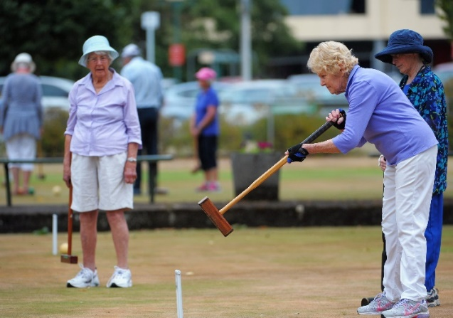
- Many have a greater appreciation for the land and history of Wairarapa than other older people.

Identified challenges and concerns that need addressing
- Kuia, koroua and kaumātua need access to resources and services they are eligible for and need
- Improved awareness and knowledge of te reo Māori and history of the area amongst residents
- Capability of councils to engage effectively with iwi, hapū and whānau
- Support for marae development
- Support new voices to talk with councils.

“There is a very account driven approach, and no-one wants to work in commission approach. Council could take leadership of this.” Ronald (Snr) Karaitiana, CEO, Hauora
There is call from Māori health leaders for a change from a contract approach to a more holistic commission approach led by councils so that a real difference can be made including – sharing data, stories and working together.
In addition, community leaders notice the lower use of mainstream services by Māori and other ethnic groups.

Goal priorities
Our community is proud of, and inclusive of, all cultures through:
- Strong relationships and partnerships between iwi, hāpu and whānau with councils
- Cultural competency and Treaty of Waitangi knowledge/training for all staff and elected members
- Supporting and capacity building of cultural groups and events.

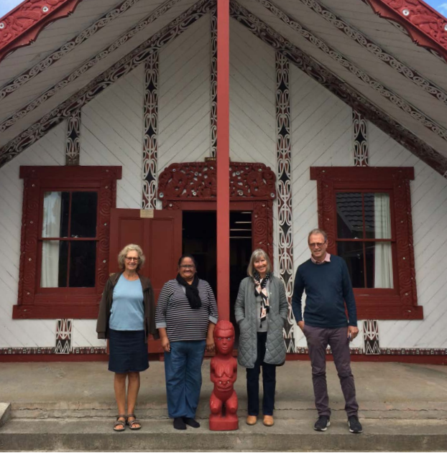

Goal Five: Housing

Whāinga Tuarima: Whakakāinga Hauora
Housing options are appropriate, healthy and accessible for older people.

Goal overview

In general, Wairarapa has a higher than average percentage of people who own their own homes and this is reflected in the 65 plus population (75% compared with 71% nationally). However, trends in home ownership show a decline across the country and this will result in more older people requiring rental accommodation, social housing or other semi-communal alternatives such as retirement villages. Despite this high rate of home ownership in the Wairarapa district, about 25% of older residents responding to our survey, identified housing as a key issue or challenge. No specific consultation was undertaken with older residents in rental or compromised housing situations.
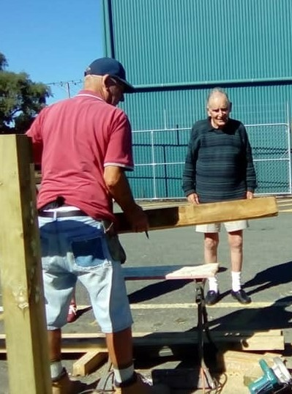
While the Wairarapa district councils have provided social housing, Carterton District Council divested its stock in 2015 and the South Wairarapa is considering changes to its funding model for housing for seniors. Hurunui o Rangi Marae has a papakāinga development in Carterton to provide affordable housing for a variety of tenants from kaumātua to young families. Masterton District Council provides 74 homes for older people from its housing stock of 86 properties. Social housing is also provided by Trust House which has around 485 homes across Wairarapa and Tararua, some of which are dedicated to older people.
Given that there is no Housing New Zealand presence in Wairarapa, the region’s ability to respond to the increasing need for social housing is limited. The region currently relies predominantly on Trust House to provide social housing.
In 2017 the Retirement Villages Association recorded 12.6% of 75 plus live in residential units (an increase of 12.4% in 2016) and 14% in the Wellington region (Wairarapa statistics not available). Nationally, the population of 75 plus is set to grow from 6% to 10% by 2033 with a subsequent need for an increase in retirement and other semi-communal living arrangements for older people.

Goal priorities
Ensure housing options are appropriate, safe and accessible for older people by:
- Housing planning and development that considers the needs of older people including housing stock, design, access and community connectedness
- Sufficient social housing stock for older people.

Goal Six: Places, Spaces and Activities

Whāinga Tuaono: Ngā Wāhi, Ngā Rēhia
Places, spaces and activities are safe, affordable and provide fun and enjoyable choices for older people.

Goal overview
Older people enjoy and are overwhelmingly attracted to the Wairarapa for its climate, sense of community, affordability and environment. An important aspect of this, is the extensive network of parks and public spaces in the Wairarapa that are owned and managed by the district councils. Older adults are deeply appreciative of these facilities and enjoy local recreation, events and opportunities and many volunteer. Consultation indicated that some groups (e.g. Māori) were less likely to have knowledge of opportunities and therefore less likely to participate.
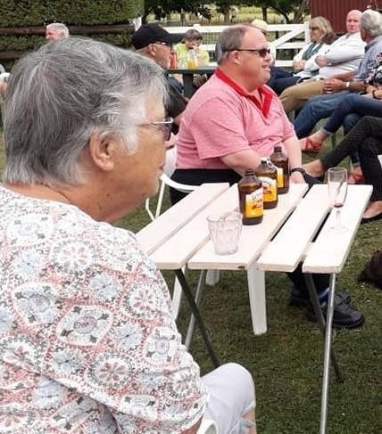
Areas of dissatisfaction included accessible journeys, seating, and toilets, parking, dog walking areas, signage and information. Residents outside of Masterton and especially in rural areas, often requested better access to transport options or mobile services of all kinds. A growing population will also require increased investment and protection of public spaces and places.
“More public seating. More sheltered areas out of the wind sun rain. Path surfaces suitable for walking sticks, walking frames.” Survey respondent, resident
Public spaces and buildings in Aotearoa/New Zealand are required by law to be accessible and satisfaction amongst residents with spaces and places was very high. Yet accessibility was one of the highest areas of dissatisfaction.
Nationally 59% of people 65 plus have a disability with physical disability being the most common. This contributes to the increasing demand for enhanced accessibility services amongst older people. Māori and Pacific Island rates of disability are even higher.
Internationally, park design is beginning to be influenced by older people (e.g. China, Finland Seniors Playgrounds) and there is a move to complement existing children’s playgrounds with equipment for older people.

Goal priorities
Ensure places, spaces and activities are safe, affordable and provide fun and enjoyable choices for older people by:
- Continued investment in accessible public spaces, places and corridors that match a changing older adult population
- Promotion of recreation opportunities for older people.

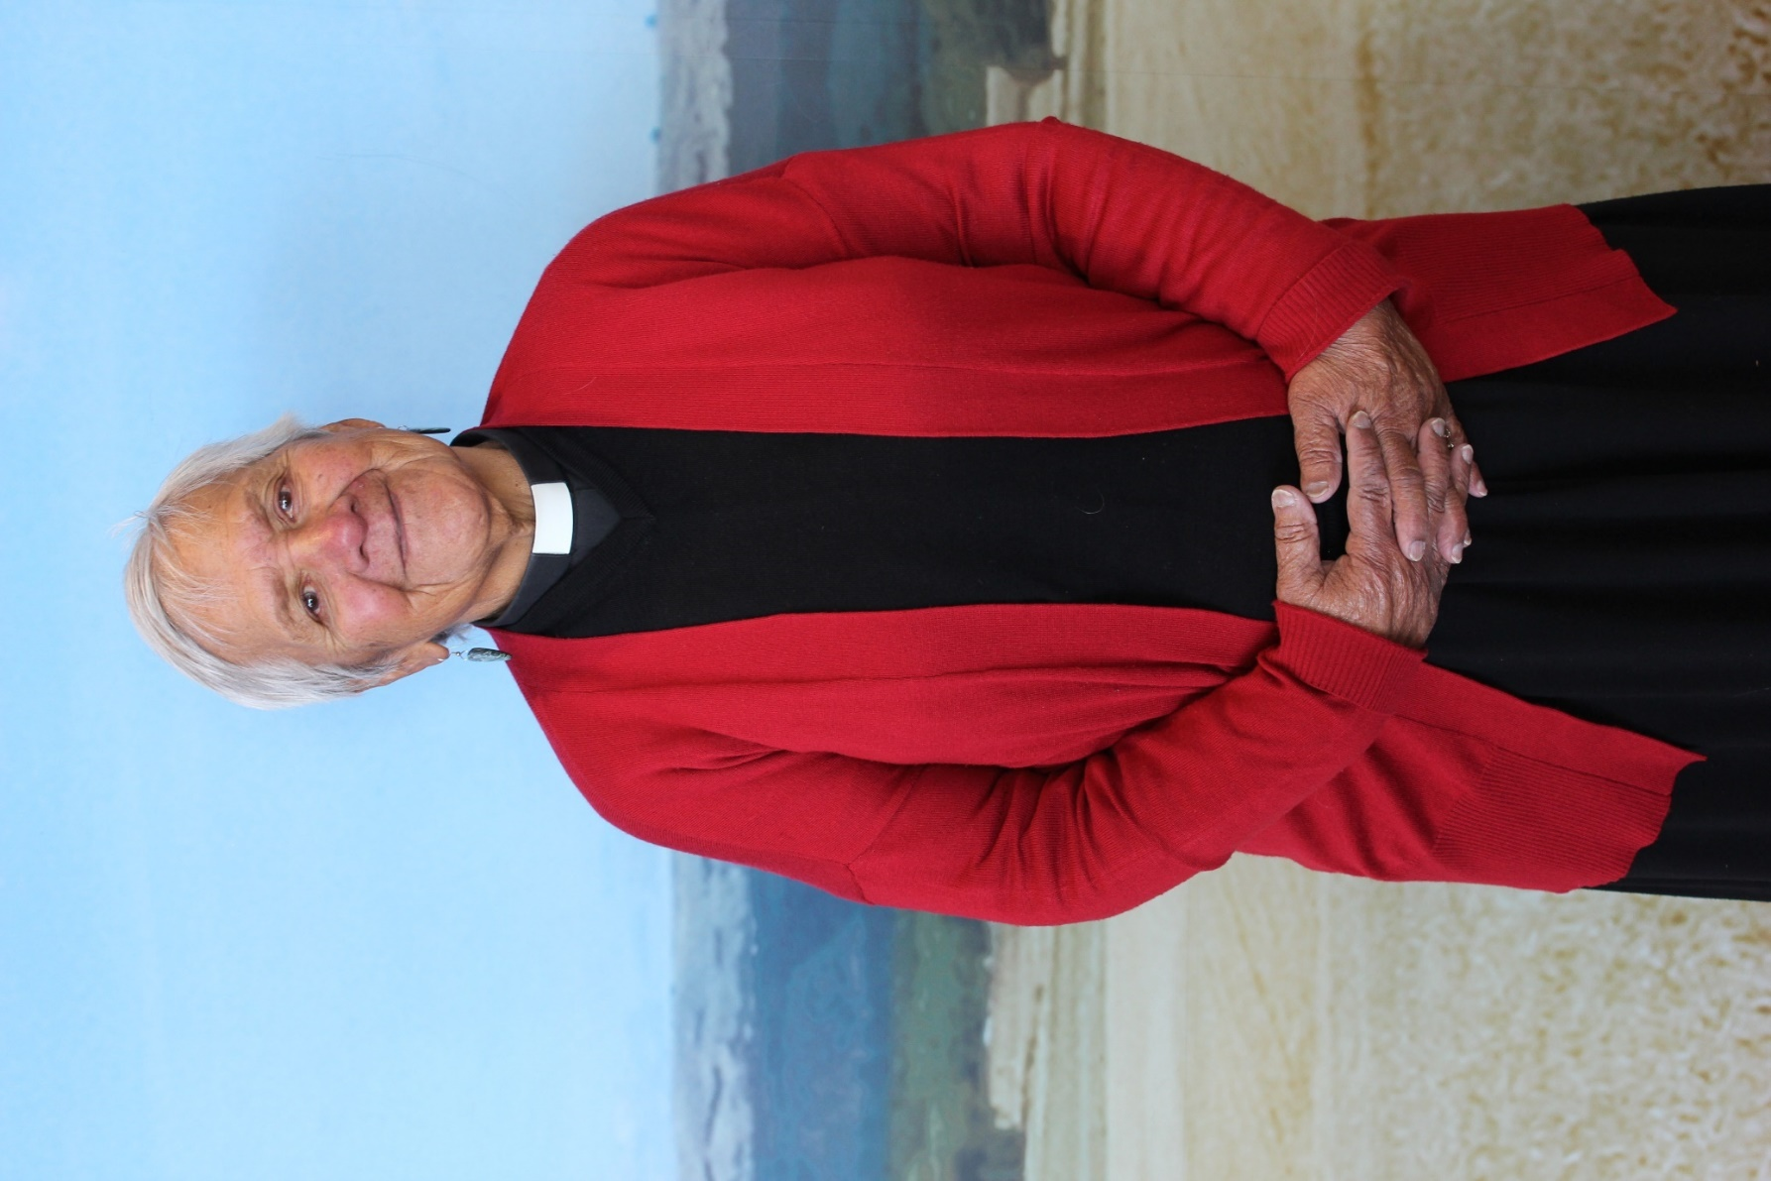

Appendices

Ngā Tāpiritanga

Appendix one: Background

Why did we do it?
The Wairarapa region has a widely dispersed population of nearly 45,000 people. In the next twenty-five years, the number of Wairarapa residents aged over 65 is expected to increase by about 79% to nearly 15,000 or 1 in 4 residents (compared to a 1 in 4.2 average in New Zealand). In addition, the Wairarapa is an increasingly attractive place for older adults to move to as they approach or become 65 plus or retire. Recognising this, Masterton District Council developed a Positive Ageing Strategy in 2011. In 2018, the three Wairarapa district councils agreed to jointly develop the Wairarapa Region Positive Ageing Strategy in consultation with the community and create linked action plans to ensure positive outcomes for older adults in the whole region. The plan is intended to ensure council work and priorities align with the current and future needs of older residents.
The Masterton District Council Wellbeing Strategy implementation plan includes a review of this plan.

How did we do it?
The Wairarapa Region Positive Ageing Strategy was sponsored by the Masterton District Council Manager Community Facilities and Activities, Carterton District Council Community Services Manager, and the South Wairarapa District Council Group Manager Corporate Support. To ensure the project engaged appropriately with Māori, feedback was sought from iwi and Māori communities including Rangitāne ki Wairarapa, Wairarapa Kaumātua Council, Te Hauora Rūnanga o Wairarapa, Ngāti Kahungunu, SWDC Māori Standing Committee, Rūnanga o Wairarapa, Whaiora Community Services/Medical Centre, residents survey and a focus group with Māori.
The consultation period began in September 2018 and was completed in March 2019.

What did we do?
It was agreed that developing the Positive Ageing Strategy would:
- Follow the principles of the WHO Age Friendly Communities Guidelines and the Office for Seniors (MSD) Positive Ageing Strategy
- Link with existing council plans, policies and projects including Long Term Plans, relevant strategies and local initiatives
- Include statistical analysis of ageing population trends in both Wairarapa and Aotearoa/New Zealand
- Include consultation with residents as well as organisations and businesses that support older adults through surveys, interviews and workshops
- Involve developing a draft strategy for feedback
- Involve finalising the strategy.
Older people have been defined as residents 65 plus, although consultation has also been carried out with residents 45 years to 65 years as the next generation of older people.

What did we learn?

The faces of ageing are changing
Based on research nationally and internationally, the Office for Seniors has identified a number of key changes that will affect our ageing population in Aotearoa/New Zealand, including:
- A rapidly rising older population
- Increasing diversity in older people
- Declining home ownership
- Older people as an increasing workforce and consumer market
- Ageing is a global issue, ageing is changing and we all need to prepare.
Based on a revision of four other positive ageing strategies from across the country, we learnt that other districts:
- All experience similar trends and issues
- Based their strategies on WHO Principles and the Office for Seniors’ National Goals
- Focused their strategy principles focus on strengths and opportunities
- Identified council collaboration with community as vital for successful outcomes.

Alignment with existing Wairarapa district council strategies and plans
A review of existing strategies and plans revealed a wide range of thinking and action to support older adults in Wairarapa.

Resident input
Communication and engagement methods for collating community views was undertaken September 2018 to March 2019 and has included:
- Distributing 1,200 postcards
- 304 online surveys completed
- 150 community conversations
- 48 participants in three focus groups
- Regular updates in community newspapers, mailouts and websites.
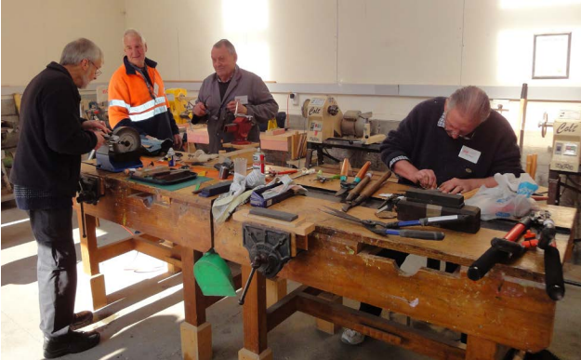
We learnt that:
- Older residents love: climate, community, environment, public spaces and activities
- They are challenged by: transport, lack of services and opportunities for social connection, employment and technology
- Iwi and Māori communities identified issues of land, relationships between iwi and councils, access to health services, housing, improving knowledge and understanding of Māori history and values.

Community leaders consultation
Consultation and engagement with community leaders from September 2018 to March 2019 was undertaken via:
- 44 in-depth interviews with 60 leaders from business, community, health and government sectors
- A community meeting with 36 leaders to share results of work so far and develop priorities moving forward.
(see Appendix Two for a full list of contributors)
We learnt that:
- Lifestyles, circumstances and expectations amongst older adults are changing
- Lack of elder networks/hubs – results in many smaller organisations working in silos
- Need for improved advice to councils from older people
- In some organisations practices are changing – sometimes this has unexpected consequences which can be positive or challenging (e.g. Ageing in Place, partnership models, transport plans)
- In other organisations (especially smaller not-for-profit organisations) many are finding it difficult to adapt to changing expectations and modern models of operation, e.g. high reliance on traditional committees and formal volunteer structures
- Unique social divides exist in Wairarapa, for example, rural versus urban, and established families versus new retirees
- Resourcing – funding and people under pressure
- Lack of strategies for older adults services outside of the health sector
- Community leaders want to see a culture shift that honours ageing, improved communication with older adults, improved design and accessibility for older adults.

Staff and elected member input
Consultation and engagement with staff and elected members was undertaken via:
- Cross-Council Officer Steering Group established in July 2018
- Cross-Council Officer Sponsors established in July 2018
- Survey of elected members and staff in September 2018
- Cross-Council staff workshop in March 2019
- Cross-Council Elected Member workshop in March 2019.
A council-wide survey of elected officials and staff across all three councils was conducted in September 2018. Of the 101 responses received, the main themes were:
- The greatest challenges identified for older adults were social isolation/loneliness, health, transport, financial, accessing services, technology, housing
- Key issues for councils to look at addressing in the future were transport, housing, social connection, technology, communication/ planning
- Working relationships existed with the following organisations: service agencies (such as Lions/Rotary (18), Rest and retirement homes (16), Age Concern (15), iwi, marae, hapū, whānau (10), medical centres (7).
The purpose of the cross-council workshops was to present findings of the research and community consultation to assist in the development of the strategy’s principles, vision, goals and actions.
Twenty-one elected members (from across the three Wairarapa Councils) attended the Elected Members Workshop. Twenty-six staff attended the council staff workshop.

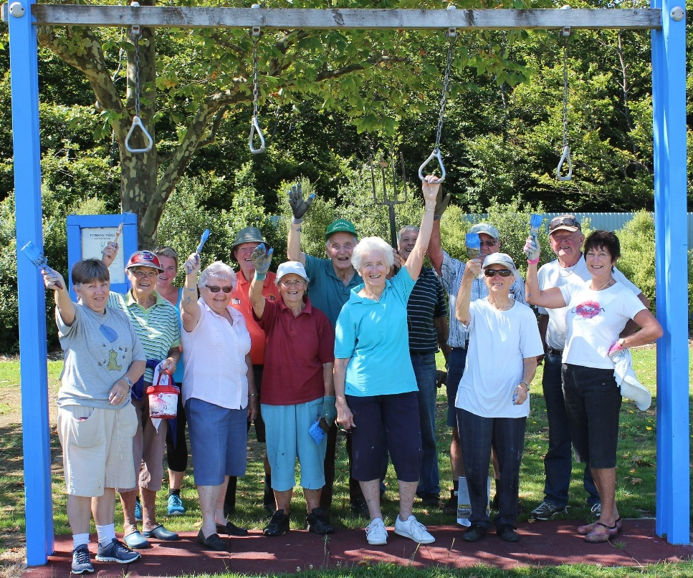

Appendix two: Contributors
Representatives from the following organisations were interviewed or contributed to community meetings:

Access Home Health
Accident Compensation
Age Concern Wairarapa
Alzheimers Wairarapa
Carter Court Rest Home and Hospital
Carterton Friendship Club
Carterton Menzshed
Carterton Neighbourhood Support
Community Patrol
Carterton Farmers Market
Carterton Time Bank
Compass Health
Connecting Communities
Craig Trust House
DHB
DHB Focus
DIA
Digital Seniors
Driving Miss Daisy
Enable NZ - Easie Living products
Enliven
E-People
Fab Feathy
Featherston Community Board
Featherston Community Centre
Wairarapa Fire Service
Gain Momentum
Gibson Sheat
Hauora
Headstones Wairarapa
Heart Foundation
IHC
King Street Artworks
Landsdowne Park Village
Landsdowne Residents Association
Life Unlimited
Lyndale Manor & Villa
Martinborough Lions Club
Masterton Rotary Club
Menzshed
Neighbourhood Watch
Police
Public Trust
REAP
Rangitāne o Wairarapa
Resilient Carterton
Roseneath Lifecare
Salvation Army
Senior Net
Sport Wellington
Sustainable Wairarapa,
Trust House
Volunteering Wairarapa
Wairarapa U3A
Wairarapa Community Law Centre
Wairarapa Green Dollars
Wairarapa Kaumatua Council
Wairarapa Stroke Club
Whaiora

Appendix three: Implementation Plan

Implementing this strategy will require:
- Dedicated staff
- A joint council action plan and three individual-council action plans. Community consultation and council workshops have identified initial actions could form the basis of this action plan once the strategy has been approved
- Project funding – some project funding may be available on application from the Office for Seniors
- A monitoring and evaluation plan – to be developed in relation to the action plan
- Governance and oversight for each council with the appropriate group i.e. MDC Strategy and Policy Group, CDC Policy and Strategy Group, and SWDC Community Safety and Resilience Working Party.
Actions will include:
- Alignment with councils’ existing strategies and plans within the control of council
- A priority for the community
- Meaningful impact on the lives of older people
- Achievable actions
- Those actions planned to begin over the next three years and that are aligned with councils’ Long Term Plans.

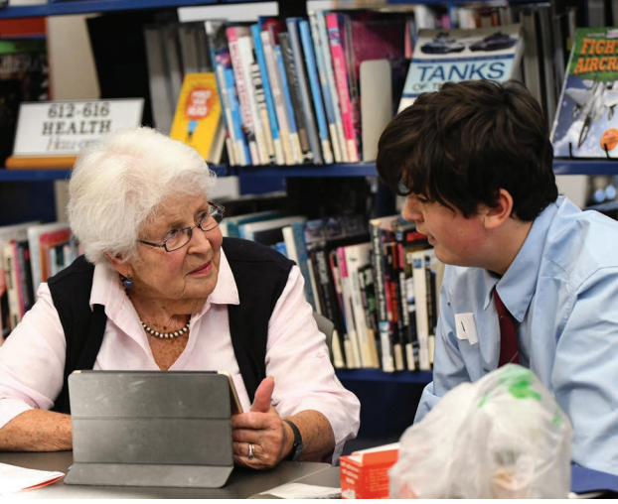

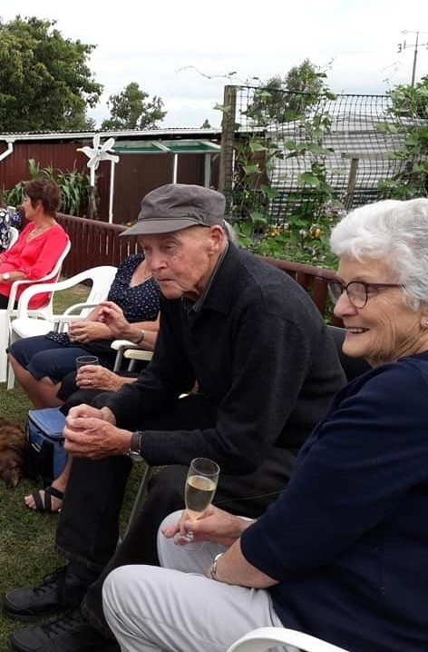

Te Hōkai Nuku WAIRARAPA REGION POSITIVE AGEING STRATEGY

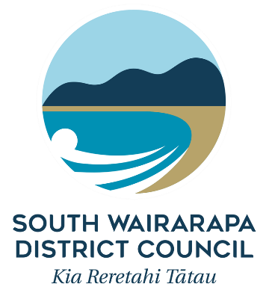

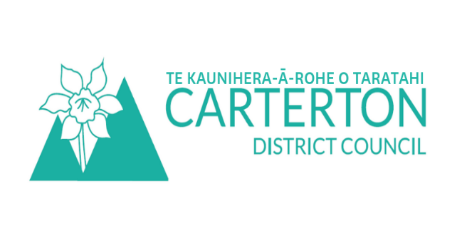

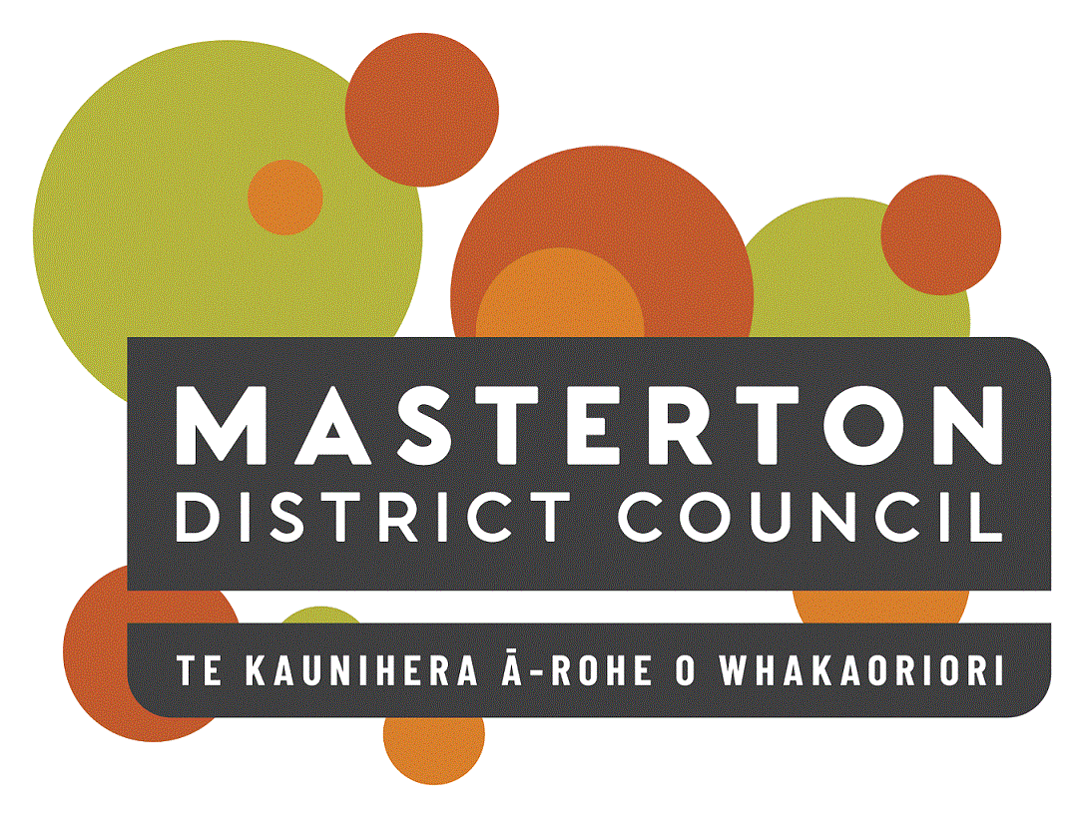

https://www.health.govt.nz/publication/new-zealand-health-strategy-2016
http://www.wairarapa.dhb.org.nz/news-and-publications/reports-and-publications/other-planning-documents/designing-our-future-together-strategic-approach.pdf
https://www.loneliness.org.nz/nz/research/typology-of-loneliness-in-nz/
https://www.stats.govt.nz/
https://www.growwairarapa.nz/
http://www.superseniors.msd.govt.nz/age-friendly-communities/index.html
https://www.stats.govt.nz/
https://www.stuff.co.nz/business/property/91778660/new-social-housing-project-located-in-rural-wairarapa-idyll
https://www.retirementvillages.org.nz/Site/industry/
https://www.sciencedirect.com/science/article/pii/S221067071831196X
https://www.athleticbusiness.com/fitness-training/playgrounds-for-seniors-popular-in-europe-asia-and-north-america.html

