Senior housing application form
Bodmin Flats, 182—184 Chapel Street
Laurent Place
Panama Village, 120 Ngaumutawa Road
Truro Flats, 190 Chapel Street
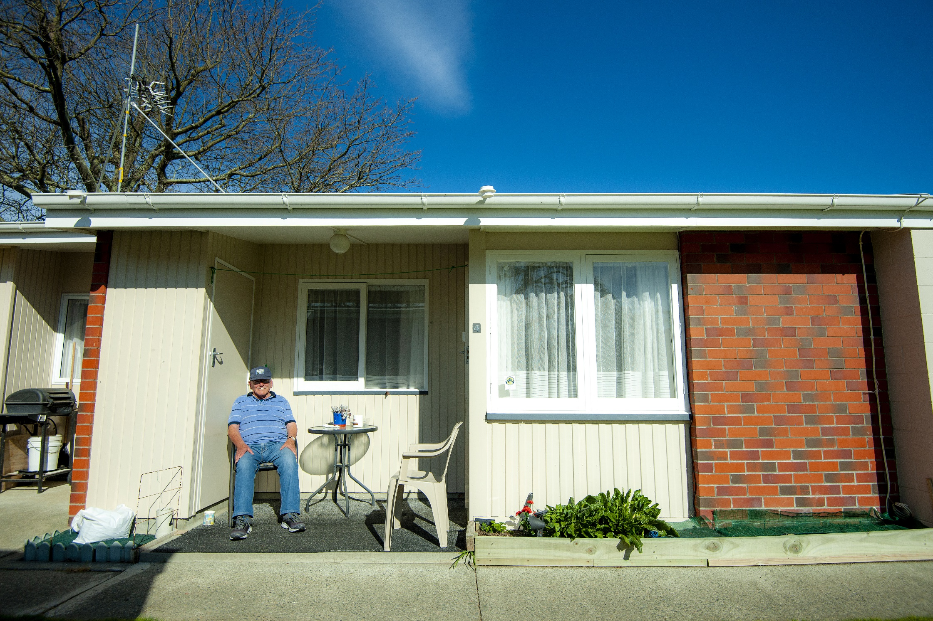
PERSONAL INFORMATION
All information received is confidential.
Name: ................................................................. Date of birth: ........................ Age:
Address:
Email:
Phone:
Next of kin:
Address:
Email:
Phone: ......................................................... Relationship:
ACCOMODATION INFORMATION
Do you have a location preference?
Bedsitter unit ............... One bedroom unit .............. Double unit with one bedroom
Please circle below, present accommodation: -
Renting Boarding Other Length of tenancy
If other, give details
Is your rent paid up to date?........................ Do you owe any rental arrears?
Name of landlord............................................................. Phone:
Address
Do you have any pets? (specify)
SOURCE OF INCOME
Are you in receipt of one or more of the following? (Delete those which do not apply)
Supported living payment Widows benefit War pension National superannuation Job seeker Other pension (state)
Number:
ASSETS
State your assets (excluding furniture and personal effects) for both husband and wife where applicable.
Do you or your spouse own any property? (specify)
Do you or your spouse have any interest in property? (specify)
Where is the property situated?
By whom is it occupied:
Have you or your spouse sold any property during the last five years?
Assets
Do you have any cash in the bank (give details)?
Do you have any investments (specify)?
Do you have any debts (specify)?
Do you have other assets (specify)?
References
Please provide full references from two people who can recommend you (not relatives).
Doctor’s Certificate
Please provide a doctor’s certificate stating your ability to live independently with or without limited support.
This application may be cancelled should you change your address and fail to notify the property division of the council.
Failure to disclose information requested in this application may also lead to its cancellation.
I/We declare that the information contained in this application is true and correct and acknowledge the right of the Masterton District Council to check the validity of the information supplied including medical information from my doctor or key worker if applicable. If misleading or false, this application will be cancelled.
Applicant’s signature:
Witness’ signature:
Date:
Date application received ............................................ Flat allocated

To make Application
You can bring this completed form in to the council office, 161 Queen Street, Masterton between the hours of 9am and 4pm weekdays, or:

Post to: Paula Beasley
Masterton District Council
P O Box 444
Masterton 5840

Email: paulab@mstn.govt.nz

Any further enquiries please phone Paula Beasley on (06) 370 6300
Privacy Act Authority

Masterton District Council
161 Queen Street
PO Box 444
Masterton 5840
06 370 6300
www.mstn .govt.nz

Name:
Address:

Email:

I/We authorise Masterton District Council
- To obtain (and any agency to disclose) a Credit Reference Check, and
- To disclose credit agency details of any indebtedness to Masterton District Council
- For Work and Income New Zealand to provide Masterton District Council upon request, your forwarding address upon vacation of a Masterton District Council property.

Signature of applicant ……………………………………………………………… Date …..…. /….….. /
Print Name

Signature of joint applicant ……………………………………………………… Date …..…. /….….. /
Print name

Senior Housing Rentals – per week

Until 30 June 2024

NAME OF COMPLEX | TYPE OF UNIT | Weekly Rental
Panama Village  Ngaumutawa Road | Bed sitter | $108.00
 | One bedroom | $115.00
 | One bedroom - double | $121.00
Laurent Place | Bed sitter | $104.00
 | One bedroom | $112.00
 | One bedroom - double | $122.00
Bodmin – Chapel Street | Bed sitter | $104.00
Truro – Chapel Street  North side | One bedroom | $112.00
 | Limited number of garages | $15.00
 | Small shed | N/C

Please note:
To take up tenancy with the Masterton District Council the equivalent of 4 weeks rental is required at the commencement of the tenancy.
Rent 2 weeks rent – first week and one week in advance
Bond 2 weeks rent

